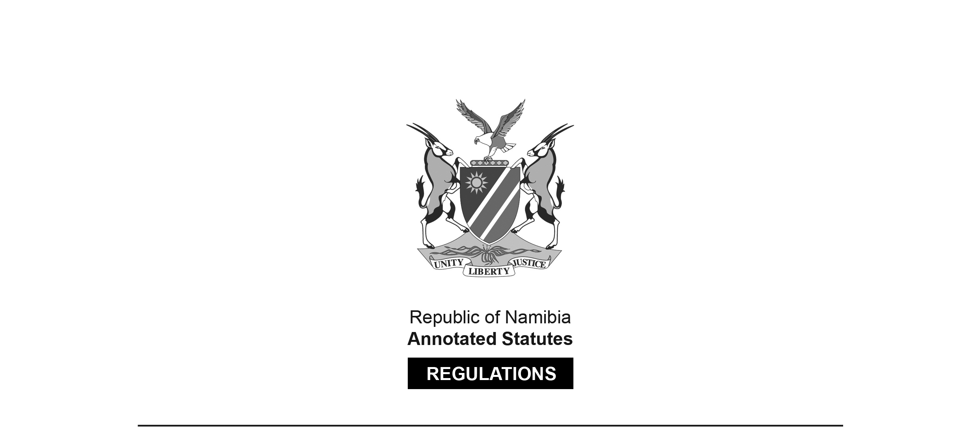
REGULATIONS MADE IN TERMS OF

Deposit Guarantee Act 16 of 2018
section 56(1)(a)

Regulations relating to Maximum Coverage Limits for Guaranteed Deposits
Government Notice 13 of 2026
(GG 7117)
came into force on date of publication: 14 February 2020

The Government Notice which publishes these regulations notes that they were made
on the recommendation of the Board of the Deposit Guarantee Authority. It also repeals
the Regulations relating to Maximum Coverage Limits for Guaranteed Deposits
in GN 24/2020 (GG 7117).

ARRANGEMENT OF REGULATIONS

1. Definitions
2. Maximum coverage limit

Definitions

1. In these regulations, “the Act” means the Deposit Guarantee Act, 2018 (Act No. 16 of 2018).

Maximum coverage limit

2. For purposes of section 40 of the Act, the maximum coverage limit is N$50 000.00 per depositor per member institution from which deposits have become unavailable.

